CAPSTONE PROJECT REPORT

RentAPlace

SUBMITTED BY: KOTESWAR DHULIPALLA

Date: 26/03/26

Batch Name: WIPRO NGA - .Net Full Stack Angular - FY26 - C4

Instructor: Mr. Ramesh Nediyadath

GITHUB LINK: https://github.com/koteswardhulipalla1/SPRINT-2

Contents
Abstract 3
1.Introduction 4
1.1 Background of Online Rental Systems 4
1.2 Purpose of RentAPlace 4
1.3 Scope of the Project 4
1.4 Overview of System Users 5
2. Technology Stack 6
2.1 Backend (RentAPlace.API) 6
2.2 Frontend (RentAPlace.Client) 6
3. System Architecture 7
3.1 High-Level Architecture Diagram 7
3.2 Client-Server Interaction 7
3.3 Data Flow Overview 8
4. Component Breakdown 8
4.1 Frontend components 8
4.2 Backend Components (ASP.NET Core Web API) 9
5. Use Case Document 10
5.1 Actors 10
5.2 Use case diagram: 10
5.3 Functional Use Case Document 11
6. Database Schema 12
6.1 ER DIAGRAM: 12
6.2 Schema table 13
7. API Endpoints 17
7.1 API ENDPOINT SUMMARY 18
8. Testing 21
8.1 Testing Strategy 21
8.2 Test Cases & Results 21
9 Sprint/Capstone Deliverables Status 22
10. Conclusion 22
10.1 Summary of the Project 22
10.2 Achievements 22
10.3 Final results 22

Abstract
Locating a rental property that suits your requirements, budget, and timeline has consistently been a lengthy and aggravating task. Many current platforms are either overly complicated for casual users or lack the personalized communication features that make the booking experience feel trustworthy. RentAPlace was created to address this specific need.
RentAPlace is a comprehensive web application that connects landlords and tenants on a unified, user-friendly platform. The platform enables property owners to showcase their listings with images, pricing details, and features, while tenants can browse, refine their search, reserve, and even communicate with owners directly within the application. After a stay ends, guests can give a star rating to assist future visitors in making informed choices.
Key elements of the system consist of managing property listings, uploading multiple images with instant feedback, real-time messaging within the app for users, tracking reservations, handling cancellations, sending email notifications, and a role-based access system that distinctly separates the experiences of owners and renters.
On the technical front, the backend was developed using ASP.NET Core 8 alongside a SQL Server database overseen by Entity Framework Core. User sessions are secured through the use of JWT tokens for authentication. The frontend was built using Angular 17, featuring a unique CSS design system styled with a warm, boutique cream theme that imparts a luxurious appearance to the platform. The initiative features a specific unit testing configuration utilizing Vitest for frontend functionality and xUnit with real database integration for backend service verification.
In summary, RentAPlace illustrates how a functional, real-world rental platform can be constructed efficiently with contemporary tools, a straightforward user journey, and robust engineering methods from the very start.

1.Introduction

1.1 Background of Online Rental Systems
People used to find places in a very different way ten years ago. They would look at ads in newspapers ask friends or visit a real estate agent. These methods were slow and limited to an area. It was also hard to compare prices or talk directly to the person renting out the place.
With the internet and smartphones things changed fast. Websites and apps started to appear that let property owners reach people without needing middlemen. People looking for a place to stay could browse options on their phones compare prices read reviews and book a place in minutes. This made things faster and more transparent.
However big platforms today are either too complicated for small property owners to use or too general to offer a personal experience. They also charge a lot of money adding cost to transactions between individuals. This created a need for a system.

1.2 Purpose of RentAPlace
RentAPlace was designed to meet this need. The goal was to build a platform that is easy to use, powerful enough to handle real bookings and transparent to make both owners and renters comfortable.
Of trying to copy big commercial platforms RentAPlace focuses on the main interaction. A property owner wants to rent out their space and a renter wants to find a place to stay. Every feature was built to support this transaction.
The application also focuses on communication. It has a built-in messaging system so renters can ask questions and get answers from owners within the platform.

1.3 Scope of the Project
The scope of RentAPlace covers the process of renting from listing a property to completing a booking and submitting a review.
Specifically the system handles:
* Account registration and secure login for owners and renters
* Property creation editing and deletion by owners
* Uploading images for property galleries
* Property search and filtering by city, type and availability
* Creating, tracking and cancelling reservations
* messaging between renters and owners
* Star rating submission after a stay
* Automated email notifications for events
The system does not handle payment processing. Pricing is displayed. The financial transaction happens outside the platform.

1.4 Overview of System Users
RentAPlace has two types of users. Owners and renters. Each has their responsibilities and access.
The Owner is someone who has one or more properties to rent out. They can add listings update existing ones upload photos and review reservation requests. They can also see messages, from renters. Respond to them.
The Renter is someone looking for a place to stay. They can browse properties apply filters view property pages send messages to owners and make reservations. After a stay they can leave a star rating.
Both roles are managed through an authentication system, which ensures that every action is tied to a verified identity.

2. Technology Stack

2.1 Backend (RentAPlace.API)
Framework: .NET 10.0 Web API
Language: C#
Database: SQL Server (Production) / EF Core In-Memory (Development)
ORM: Entity Framework Core
Authentication: JWT (JSON Web Tokens) with Auth Guards
Security: BCrypt for password hashing
Documentation: Swagger (Swashbuckle)

2.2 Frontend (RentAPlace.Client)
Framework: Angular v21.2.0
State Management: RxJS (Observables)
Styling: Vanilla CSS / Modern UI components
Routing: Angular Router

3. System Architecture

3.1 High-Level Architecture Diagram
The system relies on a standard three-tier architecture: the visual client, the business logic API, and the data storage layer.
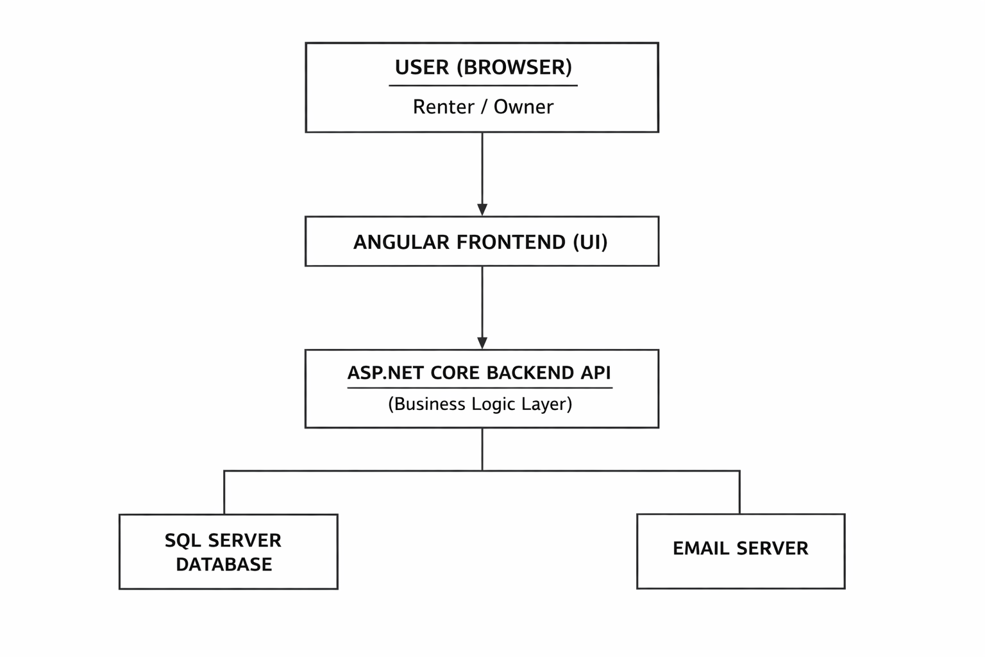
Figure 3.1.1: System Architecture
RentAPlace is built as two completely separate projects that communicate with each other over the network, rather than being tangled together in one codebase.
The Frontend (Angular) handles everything the user physically sees and clicks on. It manages the screen layouts, forms, and browser routing.
The Backend (ASP.NET Core) acts strictly as the brain of the platform. It holds the business rules, processes the data, calculates costs, and enforces security.

3.2 Client-Server Interaction
REST APIs are the only means of communication between the two parties. The frontend requests the top properties from the server via an HTTP GET request when a user navigates to the homepage. The server retrieves the data, verifies the rules, and returns a short JSON string. After unpacking that JSON, the frontend displays the property cards on the screen.

3.3 Data Flow Overview
Data travels along a straightforward, predictable route:
Input: The user enters information (such as booking dates) into a web form.
Transport: Before transmitting the data to the server, the Angular client encapsulates it in a JSON object and adds a secure authorization token.
Processing: After dissecting the token and confirming that the user is permitted to reserve the dates, the C# API prepares the record.
Storage: The C# object is converted into SQL commands by Entity Framework before being permanently stored in database tables.
Feedback: The frontend displays a confirmation screen and generates an architecture diagram in response to the server's success message.

4. Component Breakdown

4.1 Frontend components
The frontend uses small, independent components. Each part of the screen is handled separately, making it easier to manage and update the application. The authentication module controls logins and registrations. User input is checked before it is sent to the server, and after successful login, the JWT token is stored locally. It also controls what parts of the application users can access depending on their role. The homepage component functions as a landing page. It loads and displays the highest quality properties in grid format. The search bar also includes a visual representation of different categories, allowing users to filter the results by city and property type. The listing and detail section of the property constitutes the main browsing experience. The listing page reads the filter from the URL and shows the matching results. When the user selects the property, a detailed page with images, pricing information and booking options opens. It also calculates the total cost on the basis of selected dates and checks whether the user is a owner or a renter. Owner dashboards are designed exclusively for property owners. It allows you to add and manage lists in a simple form. Uploads of images are handled with a live preview system, so that users can see updates while uploading files. The messaging interface provides a chat-like system where renters and owners can communicate directly on the platform, linked to a specific property.

4.2 Backend Components (ASP.NET Core Web API)
The backend is responsible for logic, data processing, and security. It is a structured approach that remains organized in different parts of the system. The security layer checks every request received by validating the JWT token. It also applies role-based rules to ensure that users can only use the features they want to use. The authentication service and the user controller manage the user's identity. They process login requests, verify database credentials, encrypt passwords, and generate safe tokens for session management. The property service and the controller handle all property-related operations. They efficiently extract property data from the database and process image uploads by storing files and connecting them to the correct record. The reservation service manages the reservation logic. Check the availability of dates, prevent double bookings and calculate the final cost on the server side to ensure accuracy and security. The messaging and e-mail service processes communication. Messages between users are stored and managed within the system, and email notifications for important events such as booking confirmations are automatically sent.

5. Use Case Document

5.1 Actors
Renter — A registered user who searches for properties, makes reservations, sends messages to owners, and submits ratings.
Owner — A registered user who manages property listings, handles reservations, and responds to renter messages.

5.2 Use case diagram:
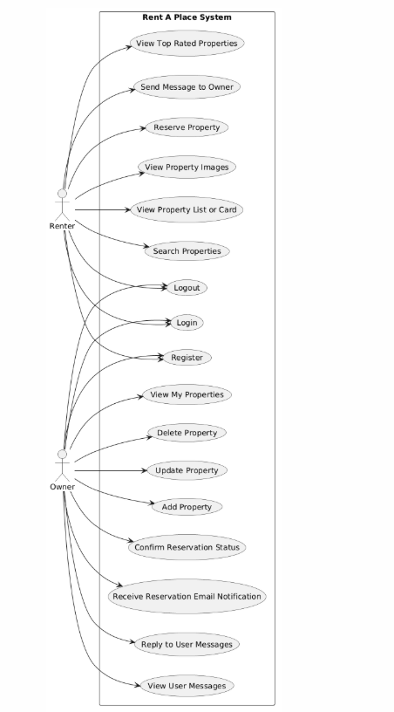
Figure 5.2.1 : Use Case Diagram

5.3 Functional Use Case Document
Use Case ID | Use Case Name | Actor | Description
UC-01 | Account Registration | Guest | Create a "Renter" or "Owner" profile.
UC-02 | Secure Login | Guest | Authenticate and receive a session JWT.
UC-03 | Property Browsing | Guest/Renter | View available listings with images & prices.
UC-04 | Advanced Search | Renter | Filter properties by City, Country, or Price.
UC-05 | Create Listing | Owner | Post new property details to the platform.
UC-06 | Image Management | Owner | Upload and sort gallery images for listings.
UC-07 | Booking Request | Renter | Reserve a property for specific check-in dates.
UC-08 | Booking Manager | Owner | Approve or cancel pending guest reservations.
UC-09 | Direct Messaging | Renter/Owner | Real-time chat regarding property inquiries.
UC-10 | Unread Notifications | Renter/Owner | Track new messages and booking status updates.

6. Database Schema
RentAPlace's database follows a standard relational design that is mainly centered around five main tables: users, properties, properties, reservations and messages. The user table is the foundation, stores identities, and distinguishes between the roles of "Renter" and "Owner". The central property table connects directly with the owner via foreign keys, with details such as titles, cities and prices, and its child table, PropertyImages, stores the file paths of the visual gallery. When the user registers for a stay, a record is created in the Reservations table that binds a specific landlord to the property along with their arrival and departure dates. Finally, the Messages table bridges the communication gap by connecting senders (renters) and receivers (owners) directly to the specific assets they are discussing, ensuring that data integrity is maintained and monitored throughout the platform.

6.1 ER DIAGRAM:
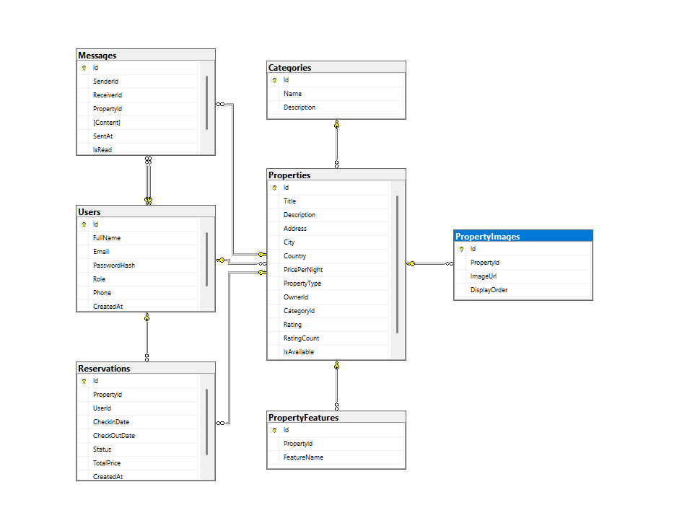
The database follows a normalized relational design, managed via EF Core migrations.

6.2 Schema table
1. Users Table
Manages user profiles and authentication details.
Column | Data Type | Constraints | Description
Id | int | PK, Identity | Unique user identifier.
FullName | nvarchar(100) | Required | User's full display name.
Email | nvarchar(150) | Required, Unique | User's electronic mail address.
PasswordHash | nvarchar(max) | Required | Securely hashed password (BCrypt).
Role | nvarchar(20) | Default: 'Renter' | User role: 'Renter' or 'Owner'.
Phone | nvarchar(20) | Nullable | Contact phone number.
CreatedAt | DateTime | Default: Now | Account creation timestamp.

2. Properties Table
Stores information about rental listings.
Column | Data Type | Constraints | Description
Id | int | PK, Identity | Unique property identifier.
Title | nvarchar(200) | Required | Title of the listing.
Description | nvarchar(2000) | Max 2k chars | Extensive details about the property.
Address | nvarchar(300) | Required | Physical street address.
City | nvarchar(100) | Required | City of location.
Country | nvarchar(100) | Required | Country of location.
PricePerNight | decimal(18,2) | Required | Rental cost per 24 hours.
OwnerId | int | FK (Users) | Reference to the property owner.
CategoryId | int | FK (Categories) | Reference to property category.
Rating | double | Default: 0 | Average user rating.
IsAvailable | bool | Default: true | Current availability status.

3. Reservations Table
Tracks booking transactions.
Column | Data Type | Constraints | Description
Id | int | PK, Identity | Unique booking ID.
PropertyId | int | FK (Properties) | The property being reserved.
UserId | int | FK (Users) | The user making the booking.
CheckInDate | DateTime | Required | Start date of stay.
CheckOutDate | DateTime | Required | End date of stay.
Status | nvarchar(20) | Default: 'Pending' | Status: Pending, Confirmed, Cancelled.
TotalPrice | decimal(18,2) | Calculated | Total amount for the entire stay.

4. Categories Table
Classifies properties (e.g., Beach-facing, Villa, Penthouse).
Column | Data Type | Constraints | Description
Id | int | PK, Identity | Unique category identifier.
Name | nvarchar(100) | Required | Name of the category.
Description | nvarchar(500) | Nullable | Brief description of the category.

5. Messages Table
Handles communication between Renters and Owners.
Column | Data Type | Constraints | Description
Id | int | PK, Identity | Message identifier.
SenderId | int | FK (Users) | User sending the message.
ReceiverId | int | FK (Users) | User receiving the message.
PropertyId | int | FK (Properties) | Optional property reference.
Content | nvarchar(2000) | Required | The text content of the message.
SentAt | DateTime | Default: Now | Timestamp of message sent.
IsRead | bool | Default: false | Tracks if receiver has seen message.

6. PropertyFeatures Table
Lists specific amenities or highlights of a property.
Column | Data Type | Constraints | Description
Id | int | PK, Identity | Feature identifier.
PropertyId | int | FK (Properties) | Property associated with feature.
FeatureName | nvarchar(100) | Required | Name (e.g., Wifi, Pool, Gym).

7. PropertyImages Table
Stores gallery images for property listings.
Column | Data Type | Constraints | Description
Id | int | PK, Identity | Image identifier.
PropertyId | int | FK (Properties) | Property associated with image.
ImageUrl | nvarchar(500) | Required | Source path/URL of the image.
DisplayOrder | int | Default: 0 | Sort order for display in gallery.

7. API Endpoints
All endpoints are documented and testable via Swagger UI at http://localhost:5209/swagger.
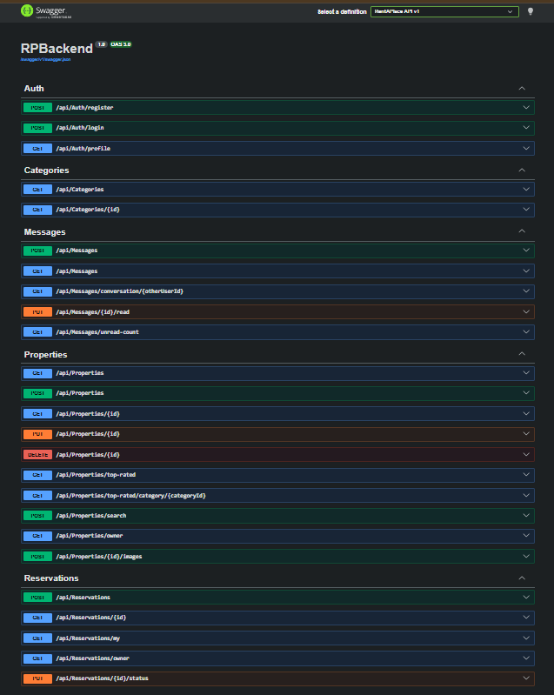

Figure 7.1 : Swagger URL

7.1 API ENDPOINT SUMMARY
1. Authentication & Profiling (api/Auth)
Method | Route | Auth Required | Description
POST | /api/Auth/register | None | Create a new user account.
POST | /api/Auth/login | None | Authenticate credentials and receive JWT.
GET | /api/Auth/profile | JWT | Retrieve profile details of the current user.

2. Property Categories (api/Categories)
Method | Route | Auth Required | Description
GET | /api/Categories | None | List all property categories (e.g., Villa, Apartment).
GET | /api/Categories/{id} | None | Get a single category with its property count.

3. Property Listings (api/Properties)
Method | Route | Auth Required | Description
GET | /api/Properties | None | Get all available rental listings.
GET | /api/Properties/{id} | None | Get full details of a specific property.
GET | /api/Properties/top-rated | None | Get listings sorted by highest rating.
POST | /api/Properties/search | None | Search properties by city, price range, etc.
GET | /api/Properties/owner | JWT (Owner) | Get all properties owned by the current user.
POST | /api/Properties | JWT (Owner) | Create a new property listing.
PUT | /api/Properties/{id} | JWT (Owner) | Update an existing listing.
DELETE | /api/Properties/{id} | JWT (Owner) | Remove a listing from the platform.
POST | /api/Properties/{id}/images | JWT (Owner) | Upload and attach images to a property.

4. Reservations & Bookings (api/Reservations)
Method | Route | Auth Required | Description
POST | /api/Reservations | JWT | Request a booking for a specific property.
GET | /api/Reservations/{id} | JWT | Get details of a specific reservation.
GET | /api/Reservations/my | JWT | Get all bookings made by the current user.
GET | /api/Reservations/owner | JWT (Owner) | Get all bookings for properties you own.
PUT | /api/Reservations/{id}/status | JWT (Owner) | Confirm or Cancel a pending reservation.

5. Messaging System (api/Messages)
Method | Route | Auth Required | Description
POST | /api/Messages | JWT | Send a private message to another user.
GET | /api/Messages | JWT | Get a list of all your active conversations.
GET | /api/Messages/conversation/{id} | JWT | Get full chat history with a specific user.
PUT | /api/Messages/{id}/read | JWT | Mark a specific message as seen.
GET | /api/Messages/unread-count | JWT | Get total number of unread messages.

8. Testing

8.1 Testing Strategy
The tests are carried out at two primary layers to maintain clarity and efficiency. Frontend unit tests were performed by Vitest. The different components are evaluated individually using the mock data instead of executing the entire application. This confirmed that the UI component worked as planned, including the correct mapping of icons, the generation of valid URLs, and the accurate calculation of dates. For the backend, xUnit was used to conduct integration tests. The tests were directly linked to actual SQL Server instances, not to a mock database. This ensures that database queries, authentication processes and connections work correctly in real environments.

8.2 Test Cases & Results
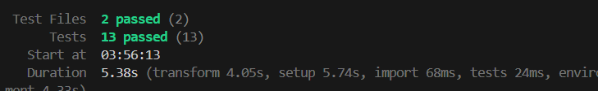
Figure 8.2.1 : Test Cases Output
A total of 16 important test cases were carried out during the test. On the front-end side, 13 test cases were successfully completed. These tests confirmed that search fields can handle empty values without errors, that category labels match correct icons, and that regular users cannot access features specific to owners. All tests were performed with complete accuracy in a few seconds. At the backend, three test cases were executed, all of which passed successfully. These include verifying the system's ability to handle large data acquisitions, ensuring that limits are correctly applied when extracting the top property, and verifying that inappropriate login attempts are properly rejected without affecting the stability of the system.

9. Sprint/Capstone Deliverables Status

Deliverable Phase | Feature / Component | Current Status
Phase 1: Setup & Design | Project Architecture & Database Schema | Completed
 | UI/UX Wireframes & Component Design | Completed
 | API Endpoint Planning (Swagger Setup) | Completed
Phase 2: Authentication | User Registration & Role Assignment | Completed
 | JWT Login System & Password Hashing | Completed
 | Angular Auth Guards & Session State | Completed
Phase 3: Core Features | Property Management (Add, Edit, Delete) | Completed
 | Multi-Image Upload System & Gallery | Completed
 | Search Bar, Location & Type Filters | Completed
Phase 4: Transactions | Booking System & Date Calculations | Completed
 | Overlap Prevention & Validation Rules | Completed
 | Real-Time In-App Messaging Interface | Completed
Phase 5: Refinement | Automated Email Notification Alerts | Completed
 | Post-Stay Star Rating System | Completed
Phase 6: Testing & QA | Backend Integration Tests (xUnit / SSMS) | Completed
 | Frontend Component Logic Tests (Vitest) | Completed

10. Conclusion

10.1 Summary of the Project
RentAPlace was developed to simplify the search and reservation process for short-term rental. The platform eliminates unnecessary complications by connecting the owner and the renter directly through a single easy-to-use system. From listing searches to bookings completion and feedback, everything is handled in one place.

10.2 Achievements
The project has successfully integrated multiple technologies into a working system. The Angular frontend provides a smooth user experience, and the ASP.NET core backend ensures appropriate business logic and security management. SQL Server databases maintain structured and reliable data storage. The system was tested under real conditions using a live database to ensure its reliability. JWT-secure authentication has been implemented and a messaging feature has been developed to enable direct communication between users.

10.3 Final results
The program is in operation and ready for use. Depending on the appropriate access control, property owners and tenants can safely use the platform. The system provides a seamless user experience and effectively manages data. In any case, RentAPlace offers a comprehensive rental solution that is simple, reliable and customer-oriented.

